1. **What is a system in software engineering?\*\*\***

**-**

A system is a group of connected parts (software, hardware, people, data) that work together to do a task.

**Software –** programs or apps

**Hardware –** computers, servers, devices

**Users –** people who use the system

**Data –** input, output, and stored information

***Example:*** A railway booking system where software, users, and servers work together.

1. **What are the key characteristics of a system?\*\*\***

**-**

**Purposeful** – Made to achieve a goal  
>> Like a ticket booking system is built to sell tickets

**Structured** – Has a planned design and process  
>> Each step is arranged clearly like in online shopping

**Interconnected** – All parts depend on each other  
>> If payment fails, order can't be placed

**Boundary-defined** – Has fixed inputs and outputs  
>> Input: login, Output: access to dashboard

**Operates in an environment** – Works with people or other systems  
>> Like weather apps use data from external sources

1. **What are the stages of the System Development Life Cycle (SDLC)?\*\*\***

**-**

**Planning** – Decide what to build  
>> Like deciding to build a school result system

**System Analysis** – Study the current system and user needs  
>> Check how marks are currently calculated

**System Design** – Make a blueprint of the system  
>> Design forms, flow, and screens

**Development** – Build the system  
>> Develop using code and tools

**Testing** – Find and fix problems  
>> Check if marks show correctly

**Deployment** – Launch the system for users  
>> Make it live for school staff and students

**Maintenance** – Fix and update over time  
>> Add new subjects later if needed

1. **What is the role of a System Analyst?\*\*\***

**-** A system analyst connects business needs with technical solutions by planning and helping in system development.

**Example:** Like asking teachers what features they need in a school system and explaining that to developers.

1. **What are the main responsibilities of a System Analyst?\*\*\***

**-**

**Requirement Gathering** – Understand what users want  
>> Talk to teachers to find out what reports they need

**Feasibility Study** – Check if it can be done  
>> Check budget, time, and skills

**System Design** – Help plan how the system will work  
>> Suggest how marks and grades will be calculated

**Communication** – Talk with users and developers  
>> Be the bridge between school and software team

**Problem Solving** – Fix existing system issues  
>> Help make the report printing faster

**Documentation** – Write clear system details  
>> Create system manuals or requirement docs

**Testing & Evaluation** – Make sure it works well  
>> Test if login and dashboard show correctly

1. **Difference between software & system development life cycle**

**-**

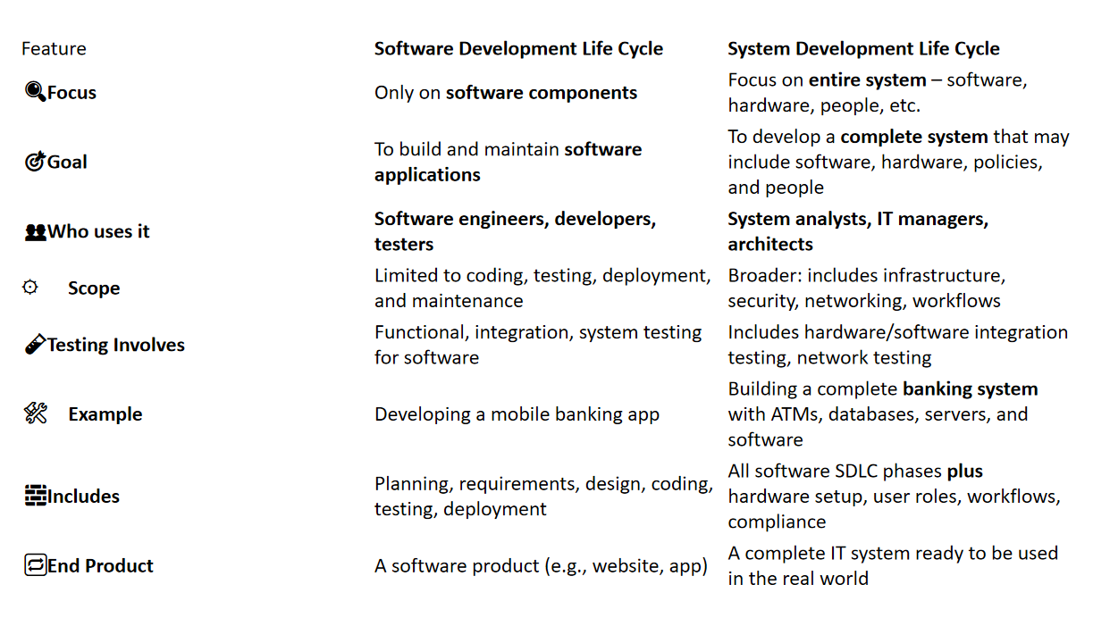

1. **Briefly discuss about MIS (Management Information System),purpose of MIS & components of MIS.\*\*\***

**-**

MIS is a system that gives managers the data they need to make good decisions.  
>>Example: A sales MIS shows weekly earnings to help plan promotions.

Purpose of MIS:

To collect, manage, and share useful information for planning and decisions.  
>> Like showing which products sell best in a shop.

Components of MIS:

**Hardware** – Devices like computers and printers  
>>Like the manager’s laptop

**Software** – Programs used to process data  
>>Like Excel or a sales tracking app

**Database** – Where data is stored  
>>Customer records, sales logs, etc.

**People** – Users of the system  
>>Managers, analysts, staff

**Procedures** – Rules for using the system  
>>Like how often data is updated

1. **What is structured analysis?& What are the tools of structured analysis?\*\*\***

**-**

Structured analysis is a method to break down a system clearly using diagrams before building it.  
>>Like using a map before starting construction.  
  
Tool Structure:

**DFD (Data Flow Diagram)** – Shows how data moves  
>>Shows login data going to database

**ERD (Entity-Relationship Diagram)** – Shows data and links  
>>Shows student linked to class and result

**Data Dictionary** – Explains what each data means  
>>“Student ID” means a unique roll number

**Process Specification (P-Specs)** – Explains each process  
>>Describes how marks are calculated

**Decision Trees/Tables** – Show conditions and actions  
>>If attendance < 75%, show warning

1. 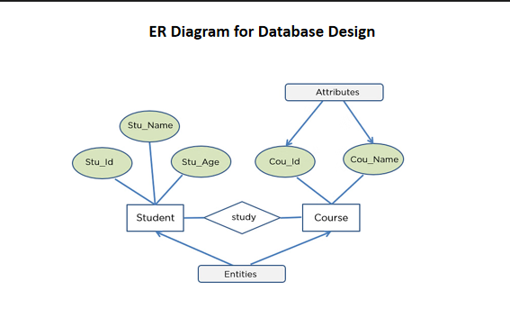
2. 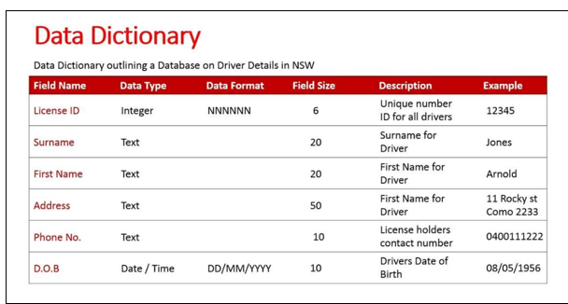
3. 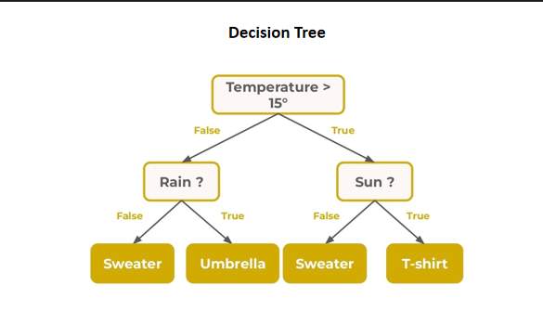
4. **What is Cost/Benefit Analysis (CBA) in system engineering?What is included in Cost/Benefit Analysis?What is the purpose of Cost/Benefit Analysis?**

**-**

CBA compares project **costs** vs. **benefits** to see if it's worth doing.  
>>If a new system costs 50k but saves 80k, it’s a good deal.

It includes:

**Costs** – Hardware, software, salaries, training  
>>Buying computers or paying developers

**Benefits** – Saves time, reduces errors, better planning  
>>Faster result processing saves hours of work

Purpose:

To check if the system gives more value than it costs.  
>>Only approve the project if benefit > cost.

1. **What are the stages of system design?\*\*\***

**-**

**Preliminary Design** – Plan the main structure  
>> Layout of modules like login, result, fees

**Detailed Design** – Design the internal parts  
>>What each page or report will show

**Interface Design** – Plan user interaction  
>>Where buttons and inputs will be placed

**Database Design** – Plan how data will be stored  
>>Tables for students, teachers, subjects

**System Architecture** – Decide tech setup  
>>Choose servers, network, and security

**Review** – Check if design meets goals  
>>Recheck if everything needed is included